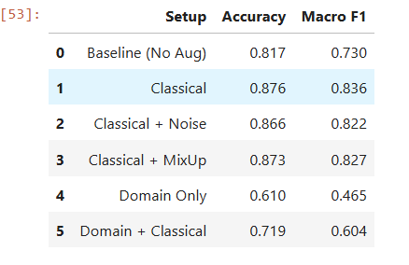
Classical geometric and photometric augmentation more effective for retinal disease classification.--> is essential for retinal disease classification, whereas heavy preprocessing and artificial mixing strategies may degrade or effect anatomical feature learning.
For remaining why not because --->
Retinal images are high-resolution medical images.
**Adding synthetic noise or more advanced method leading to :
- Distort micro-lesions
- Corrupt vessel boundaries
- Introduce unrealistic artifacts

Augmentation necessary?
It significantly improves generalization and minority class performance in small, multi-class medical datasets.

Beyond accuracy,
- Improved class balance (Macro F1 gain)
- Reduced overfitting
- Better cross-validation (stability mainly)
- Increased robustness to real-world acquisition variability
- More reliable feature learning.

